|  |  |  |  |  |  |
| --- | --- | --- | --- | --- | --- |
| Date | 6-Dec-22 | | | Tester Name | Andrew McLaughlin |
| Environment | Penfax - Test | | | Login used |  |
| Operating System | Select OS | Version: | Update: | | |
| Software Used | Select Software | Version: | Update: | | |
| Select Software | Version: | Update: | | |
| Release version | 22.4.1 | | | | |
| Title | Pays member correctly by Cheque | | | | |
| Test Type | Regression | | | | |
| Test Scenario | Pays member correctly by Cheque | | | | |
|  |  | | | | |
| Expected Results |  | | | | |
| Pass/Fail | Pass | | | JIRA# | N/A |

Describe your steps with screenshots:

Member has an EFT Payment Instruction Set Up 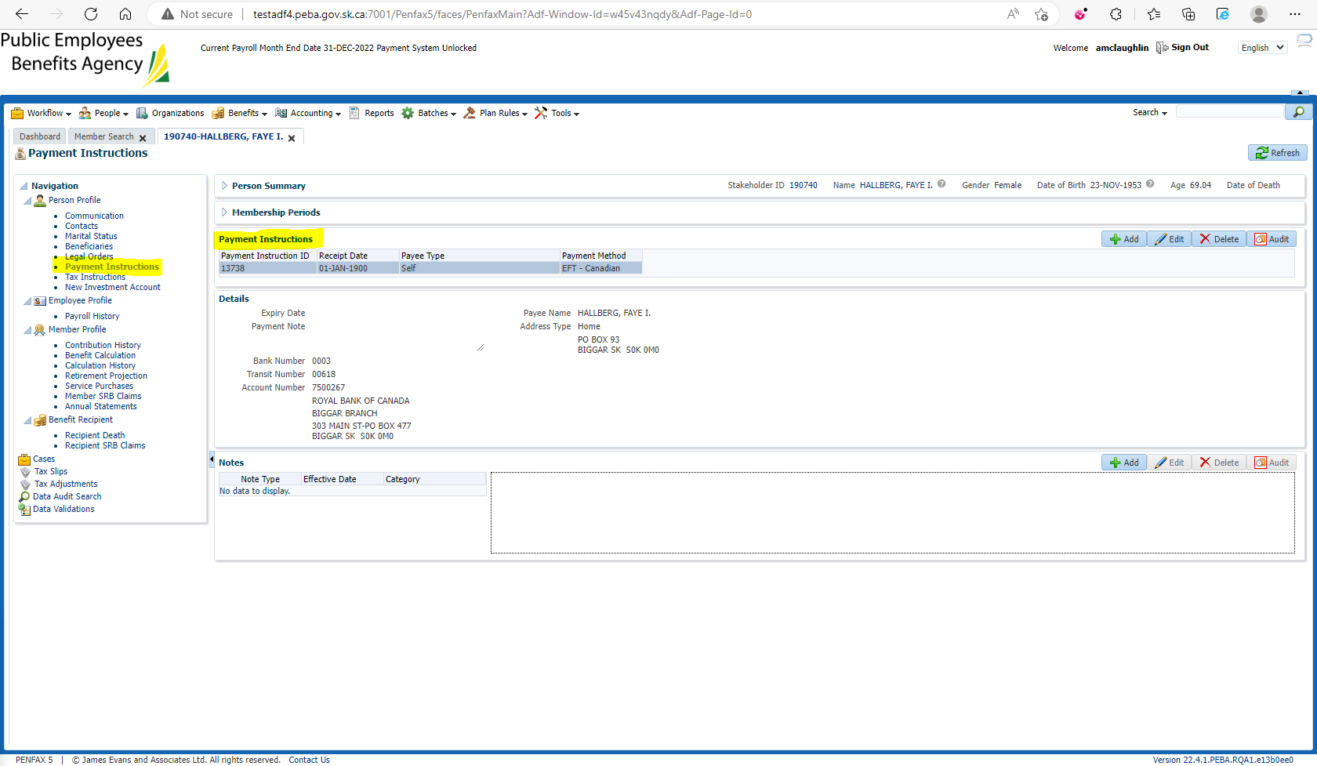

Add a cheque payment instruction 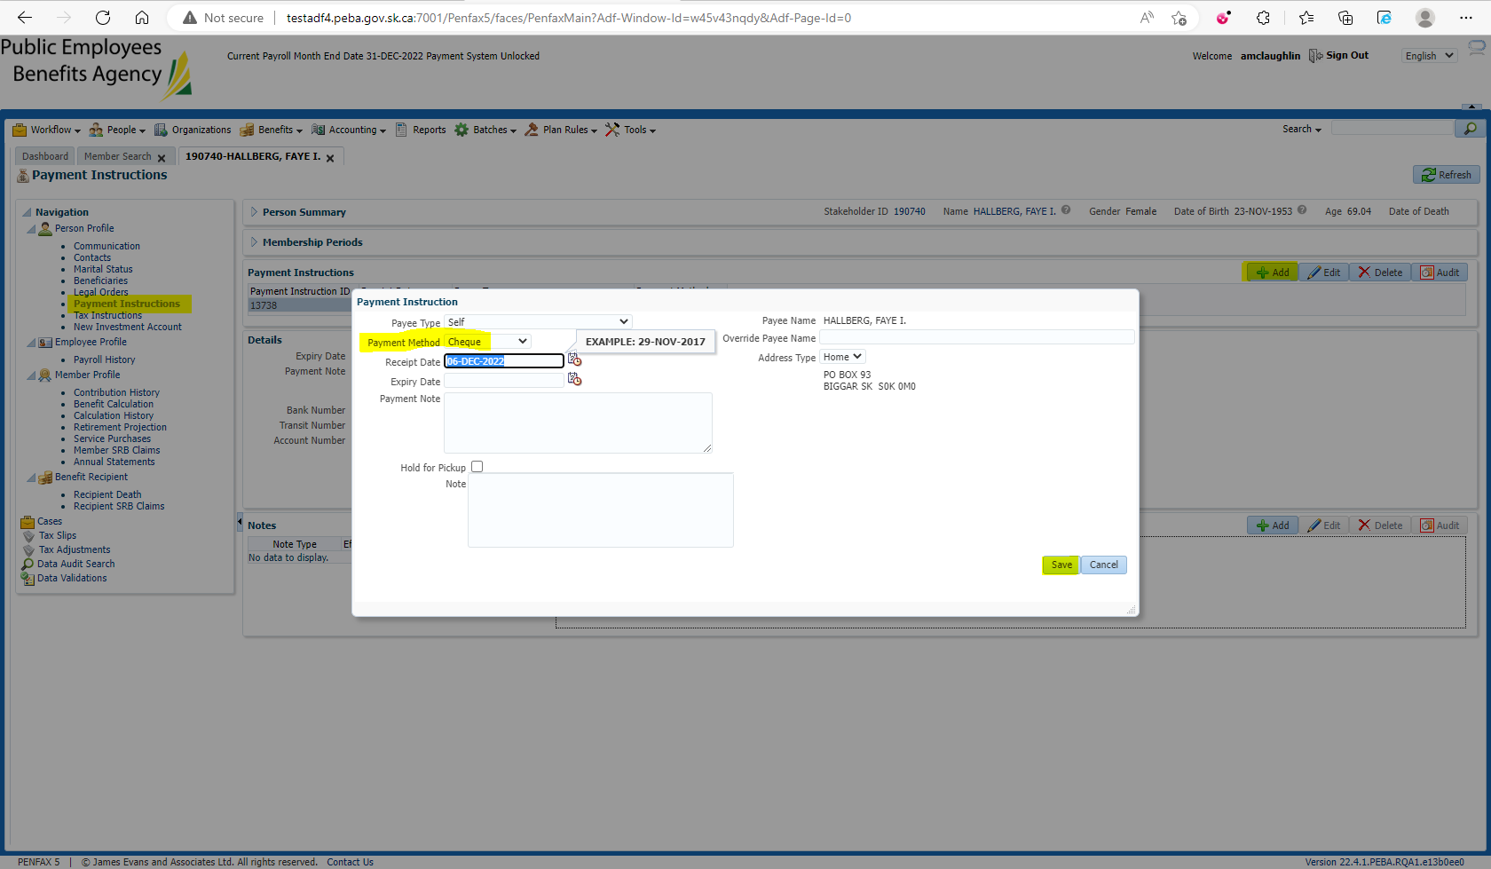

Open the Payment ID of the payment needing to be replaced in Benefit Recipient > Payment History 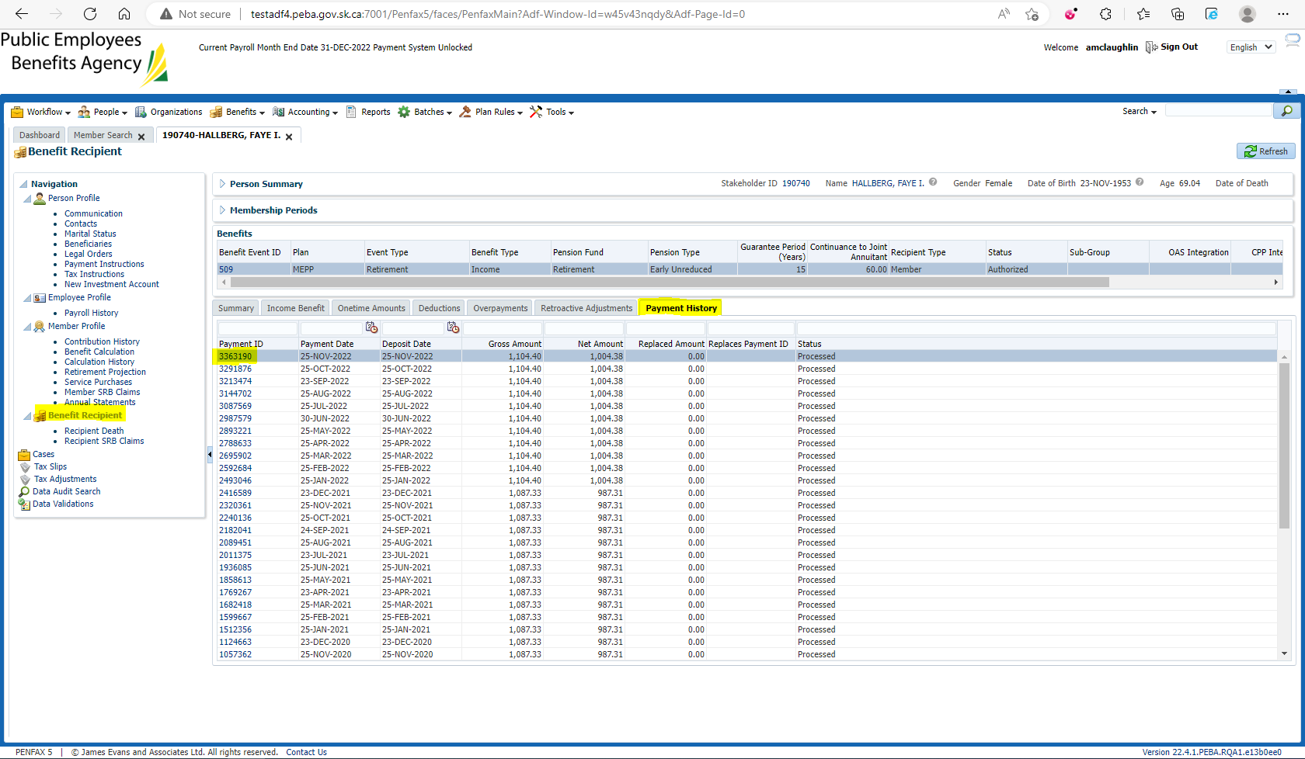

Replace the payment 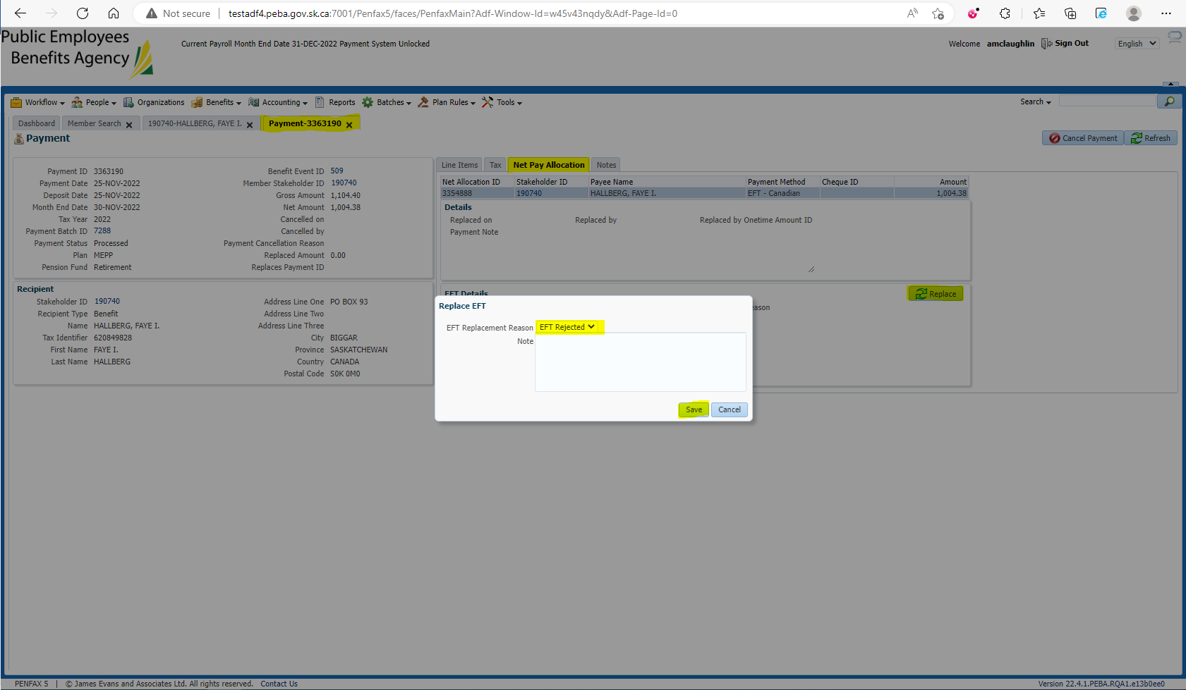

Edit in payment/tax instructions, Submit for Approval, and Approve the Replacement Payment created under Onetime Amounts tab 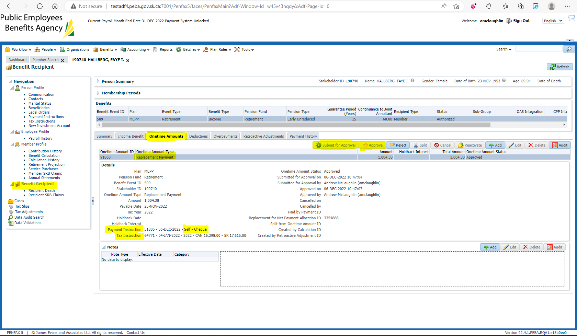

Wait for payroll to run and check the member’s Payment History to ensure the replacement payment has been issued. Make sure that the new Gross amount is equal to the previous Net amount because we don’t pay taxes twice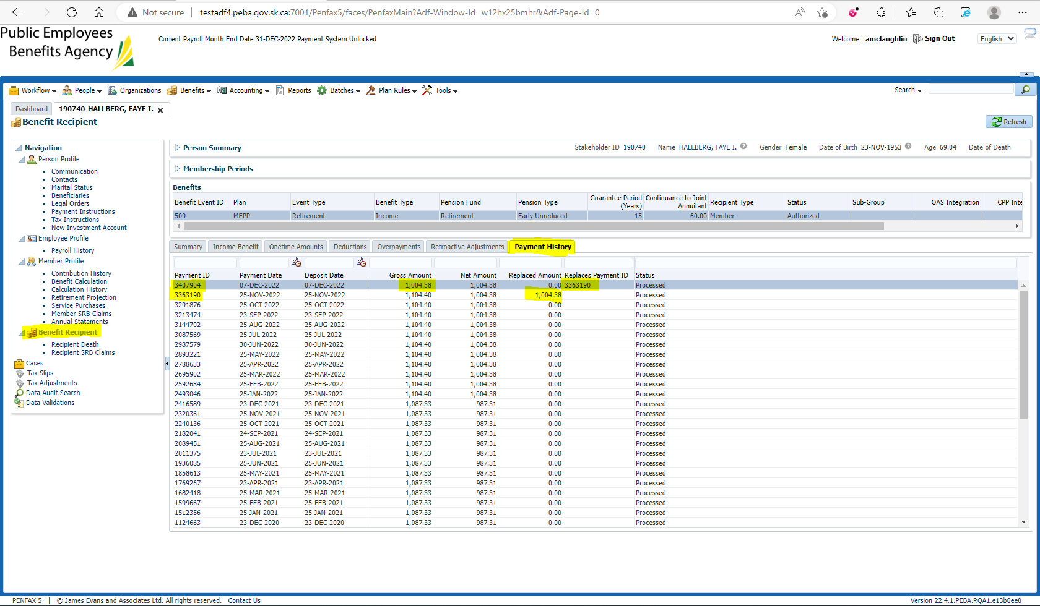

Replacement was via Cheque 